What is Computer?

Introduction

A computer is an electronic device or in general, it’s a machine. A machine is a tool that makes people’s lives easy. Many machines do it tangibly. But a computer makes it in an intangible way. This requires a computer to come up with four tasks. These tasks are **receiving input, storing, processing and giving output**.

| **Rossum** |
| --- |
| *The Computer* |

Every input and output of a computer is effectively a type of information, which can be represented by on or off electrical signals or 1's and 0's. While you are recording your voice, the computer stores your voice as on and off electrical signals (0's and 1's). Then when you want to listen to your voice computer outputs your voice as on/of electrical signals.

| **Rossum** |
| --- |
| *The Computer takes an input and convert them to electrical signals (0's and 1's)* |

Input is a form of data. Data, in a simple physical world term, is a small electrical charge. It’s either on or off, one or zero. So, the data on the cable could take two possible values. Two cables take four possible values (on-on (1-1), on-off (1-0), off-on (0-1), off-off (0-0)). Three cables take 8 values. N cables take 2 powered by N number of values. The possible number of values are determined by the base possible number of values. When the base is 2, it's called **Binary Number System**. If we compare it with the Decimal Number System, we should take a look at the same example. If a cable out of 3 could carry 10 values, the total number of possible outputs become 1000 values.

Computers have two main parts. These are **hardware and software**. Hardware and software work together. Software, with its set of instructions, controls hardware. Hardware, with its components like screen, printer, microphone, and speaker, obeys the instructions. If we look at the hardware, we will see some major parts like **Central Processing Unit (CPU), Memory (Main Memory, Random Access Memory or Primary Memory... All are the same), Storage Devices, Input Devices (like mouse and keyboard), Output Devices (like monitors and printers), Communication Devices (like modem or Network Interface Card (NIC))**. All of these components are connected via **Bus System**. Bus System is a kind of complex road system which delivers **data and power** among all of the systems inside the computers.

| **Rossum** |
| --- |
| *The Computer architecture* |

Q: What is a computer?  
A: A computer is an electronic device that can come up with four tasks. These tasks are receiving input, storing, processing and giving output.

- Interview Q&A

Q: What is a computer?  
A: A computer is an electronic device that can come up with four tasks. These tasks are receiving input, storing, processing and giving output.

- Interview Q&A

Hardware Components

Chips and Transistors

Computers have two main parts: **Hardware** and **Software**. "Hardware" refers to the physical parts of the computer, and "software" refers to the code that runs on the computer.

Modern computers use tiny electronic components that can be etched onto the surface of a **silicon chip**. Chips are packaged in plastic, with little metal legs. Tiny wires connect the chip to the outside.

| **https://docs.google.com/uc?id=1dnd_ObRKRJTXyzzf0NfZDeAEi-4lE2FG** |
| --- |
| *The Silicon Chips* |

The most common electronic component is the transistor which regulates current or voltage flow and acts as a switch or gate for electronic signals. The transistor is a "solid-state" device, meaning it has no moving parts. It is a basic building block used to construct more complex electronic components. For example, chips can contain billions of transistors.

Q: What is Computer Hardware?  
A: Computer hardware is what you can physically touch. Hardware is the collection of physical parts of a computer system. This includes the computer case, monitor, keyboard, and mouse. It also includes all the parts inside the computer case, such as the hard disk drive, transistors, chips etc.

Q: What is Computer Hardware?  
A: Computer hardware is what you can physically touch. Hardware is the collection of physical parts of a computer system. This includes the computer case, monitor, keyboard, and mouse. It also includes all the parts inside the computer case, such as the hard disk drive, transistors, chips etc.

- Interview Q&A

- Interview Q&A

### Central Processing Unit

The Central Processing Unit (CPU) is the brain of the computer. It reads the data from the memory, processes and writes the output back in the memory. It controls all the software and hardware properties. The CPU has two parts to accomplish these tasks. One is **Arithmetic/Logic Unit** and the other one is the **Control Unit**. Control Unit controls the actions of all other components, whereas the Arithmetic/Logic Unit makes the logical and arithmetic computations. The arithmetic computations consist of **addition, subtraction, multiplication and division**. And the logical computations consist of **comparisons**.

Physically, a CPU is a collection of millions of transistors which are like tiny electric switches. For example, Intel i7 processor would have roughly **2.1 billion transistors**. These switches process the data at a constant rate of speed called operating frequency. The clock rate typically refers to the frequency at which the clock generator of a processor can generate pulses, which are used to synchronize the operations of its components, and is used as an indicator of the processor's speed. This duration shows how to pull apart and interpret a data sequence. A data series containing consequent zeros or ones could be counted with the pulses of this frequency clock. A computer’s calculation power stems from this ability. The computer manufacturers try to increase the number of CPUs to enhance this ability.

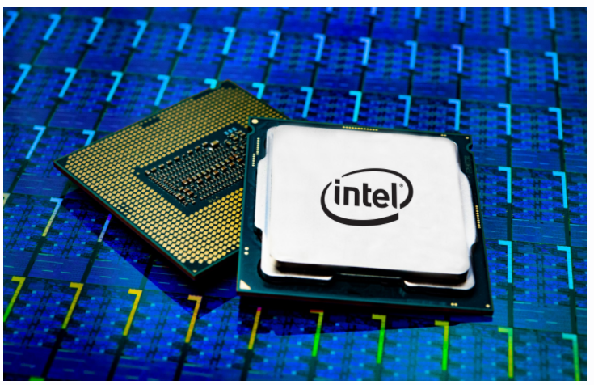

The Intel Processor

Memory

Memory is the worksheet of a computer. Before it’s processed by the CPU, the data should be written to that worksheet. Memory also can be called Random Access Memory (RAM). RAM store data **temporarily**, data is lost when the computer power is turned off and it is called "random access" because any storage location can be accessed directly.

RAM is like a human's short term of working memory, where you keep track of things going on right now. Like whether or not you had lunch or paid your phone bill.

The memory is divided into small parts like the drawers of a closet. Normally in your bedroom, drawers stores shoes, singlet, pajamas, etc. In your computer, every drawer stores 1's and 0's, it takes just **8 bits or 1 byte** of data. Every drawer has a **unique address** just to find out the necessary data. The more drawers a closet (memory) has, the more room exists for operations.

| **https://docs.google.com/uc?id=1czUi8I-tM9yeTIoF69ItnCuKXU33Drrb** |
| --- |
| *Physical Memory Simulation* |

Storage Devices

In contrast to memory, storage devices don’t let the data be wiped out after the power is turned off. They can **store the data permanently**. The storage devices have different forms. In general, they are divided into three. These are **Magnetic Disk Drives, Optical Disk Drives, Universal Serial Bus flash drives**.

While Optical Storage media are cheap and removable, they have even slower latencies then magnetic storage and lower capacity as well. Another type of long term storage is Solid State drives like Solid State Drives (SSD). These have no moving parts, they store data by electrical charges.

| **https://docs.google.com/uc?id=1JFR8H3TYu21jqpyJFolfTXTImkCvTviU** |
| --- |
| *Magnetic Disc Drive* |

In magnetic storage data is stored as a magnetic pattern on a spinning disc. But because the disc must rotate to where the data is located in order to be read the latency such drives is slower than SSD.

The newest and the fastest memory type of long term storage are Non Volatile Memory Express Solid State Drives(NvME SSD). NvME perform many of the input/output operations in parallel

Comparing with the memory, a storage device can have **much more amount of space** to store but the problem in here is the time to read and write. The **memory is much faster than the storage device**.

**Note:** If we haven't had persistent memory devices, we wouldn't be able to look at old Instagram posts = ***The End of the world...***

| **https://docs.google.com/uc?id=1D-9Ye1vHOgvZWvVXoGkqviRihdT3qsNs** |
| --- |
| *NvME SSD* |

Q: Can you give us examples of persistent and non-persistent storage devices?  
A: Random Access Memory (RAM) is an example of non-persistent storage and Hard Disk Drive(HDD) or Solid State Disks (SSD) are persistent storage examples.

- Interview Q&A

Q: Can you give us examples of persistent and non-persistent storage devices?  
A: Random Access Memory (RAM) is an example of non-persistent storage and Hard Disk Drive(HDD) or Solid State Disks (SSD) are persistent storage examples.

- Interview Q&A

### Input and Output Devices

Input and output devices are the interfaces to communicate with the outside world. Keyboard and mouse are widely used for input, while the monitor and printer are used for output.

**Keyboard**

The keyboard is the tool for entering input to the computer. This input could be a character, a number or up, down, right, left value. Some of the keys don’t cause an input but have the ability to change the value of another key when pressed together. These keys are called **modifier keys** (such as Shift, Alt, Ctrl and Cmd). There is also a Function Key. Function Key operates in a different way defined by the software that is used at that moment.

**Mouse**

The mouse is a graphical pointing device to click on a clickable object and start operation.

**Monitor**

The monitor displays text and graphical information. It’s a **human-machine interface** and the **main output area** for the operations in the computer. The screen **resolution** and the **dot pitch** are two features for a qualified monitor. The **resolution shows the number of pixels** in the horizontal and vertical axis of the screen.

A pixel is the smallest colorful part of a picture. The higher the resolution, the better the image quality is.

Communication Devices

Computers can talk to each other via communication devices like **fiber optic cables, digital subscriber line (DSL), a cable modem, network interface card (NIC), a wireless adapter and from satellites**.

DSL uses the phone lines to connect to the internet, A cable modem uses **a separate cable for connection** and it is a faster communication type comparing to DSL.

*Fiber Optic Cables* are special cables, they are like glass and data transferred as fast as laser light on glass. It's very fast for data transfer compared with DSL or cable modem. Fiber Optic cables are widely used for communication.

A **router** is a networking device that forwards data packets between computer networks.

A network interface card **connects a computer to a local network** (Local Area Network (LAN)). LANs are used for connecting computers in a limited range.

A communication satellite is an artificial satellite stationed in space for the purpose of telecommunications.

| **https://docs.google.com/uc?id=10N4PaekvM2GNr-seKIKc9lYZDFxnucaD** |
| --- |
| *Different type of communication devices* |